Assignment 1(COS)

Problem 1

1. cd home(will open home directory)

ls(list out all the folders inside home)

cd cdac(opens cdac directory)

mkdir LinuxAssignment(creates a new directory called LinuxAssignment)

b) cd LinuxAssignment(opens the directory)

nano file1.txt(creates a .txt file named file1)

cat file1.txt(displays the content of file1)

c) mkdir docs(creates a docs directory)

d)cp file1.txt docs/file2.txt

e) assuming ownership is with a user named user1. Current user is cdac.

sudo chown cdac file2.txt

f) ls -l(all contents of LinuxAssignment directory) cd / (lists all contents of root directory

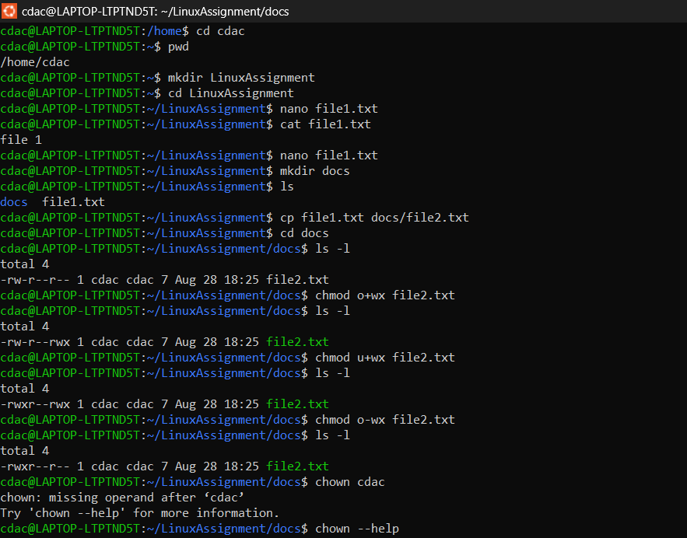

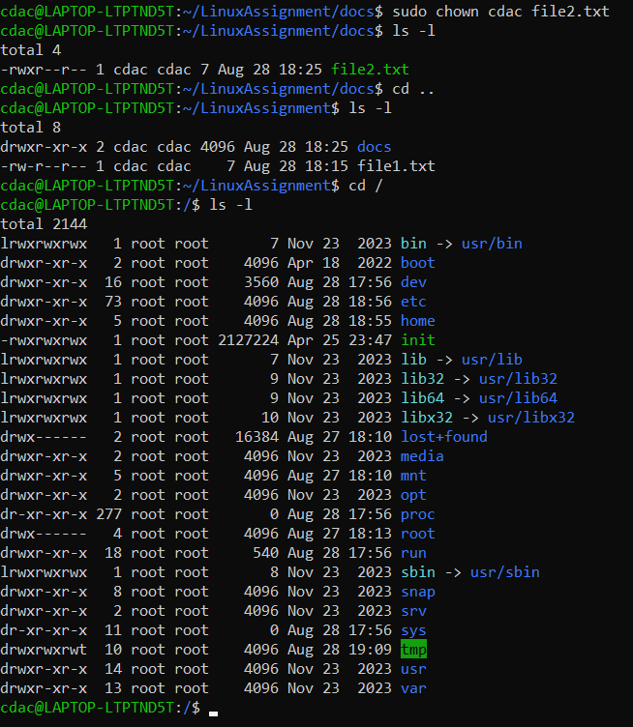





g) Currently in LinuxAssignment directory

cd ..

find LinuxAssignment -type f -name “\*.txt”

(will give 2 .txt files),editing both file1.txt file2.txt to contain the word file

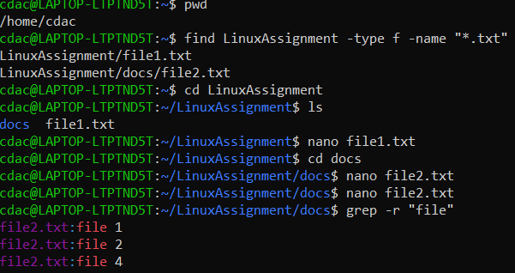

h) timedatectl (displays current date time)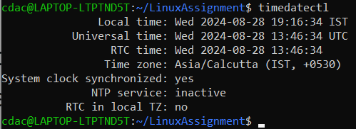

i) ip addr show (shows ip address)

ping localhost (pings the localhost)

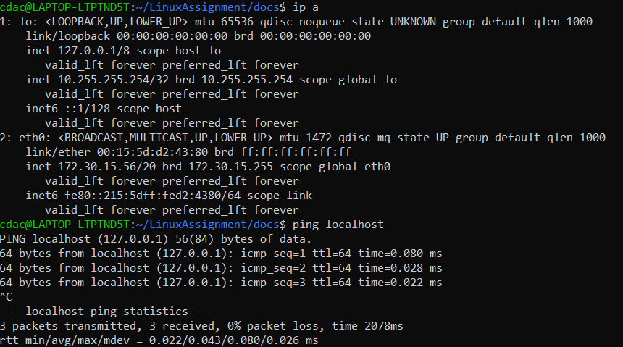

j) use sudo apt update to update all packages and dependencies

sudo apt install zip (installs zip)

zip -r (zipped folder name) (directory to zip)

to unzip, use the following commands

unzip (zipped folder) -d (destination folder)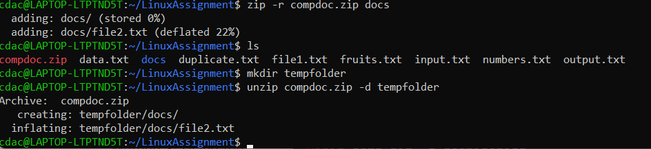

k) replaced the word “test” with “odi” in the file1.txt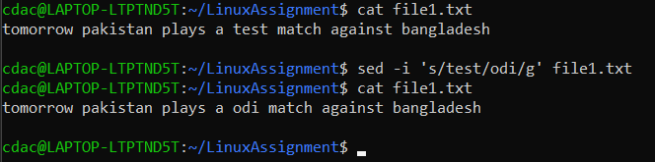

Problem 2

a) head data.txt (generates first 10 lines of file)

b) tail -5 data.txt (to generate last 10 lines)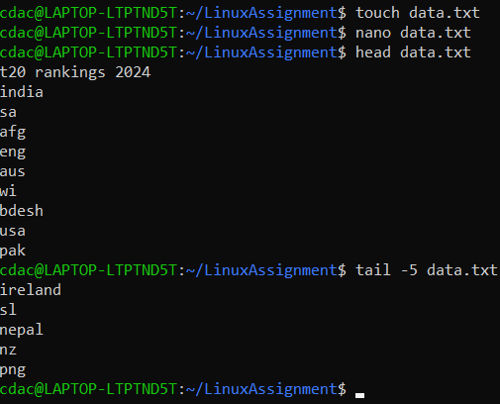

c. head -15 numbers.txt

d. tail -3 numbers.txt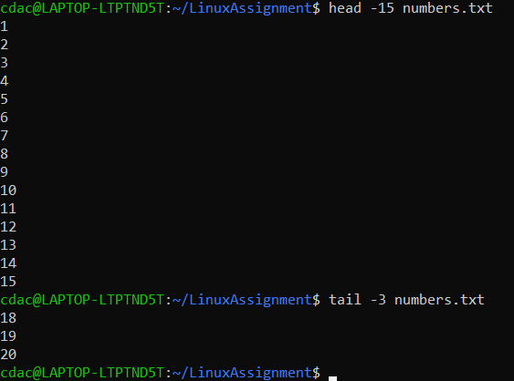

e. tr ‘a-z’ ‘A-Z’ < input.txt > output.txt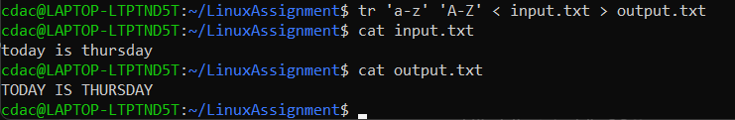

f. using uniq -u command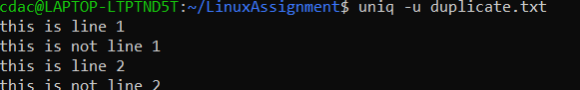

g.using uniq -c command. -c argument returns the occurences of each fruit